Wireframe Documentation

Amazon Sales Data Analysis

[AUTHOR NAME]

[AUTHOR NAME]

# Contents

1. Key Insights ............................................................................................................................................... 3
   1. Cards ................................................................................................................................................... 3
   2. Monthly Sales Trend ........................................................................................................................... 3
   3. Revenue by Country ............................................................................................................................ 4
2. Sales Analysis ............................................................................................................................................ 4
   1. Revenue vs Sales Quantity can be drilled through year , month and quarter .................................... 5
   2. Data Table of countries based on Revenue, YOY sales, Revenue Contribution, Profit contribution.. 5

3.Customer Analysis ...................................................................................................................................... 6

* 1. The revenue, sales quantity, Last purchase date of selected customer ............. **Error! Bookmark not defined.**
  2. Revenue categorize by region ............................................................................................................ 6
  3. Data table for customer based on revenue contribution , profit contribution. ................................. 7
  4. Top products tooltip for selected customers ...................................................................................... 7

1. Product Analysis ........................................................................................................................................ 8
   1. Top 20 Product slicers w.r.t revenue .................................................................................................. 9
   2. Detail Cards of Sales Quantity, YOY Sales Growth%, Profit Margin .................................................... 9
   3. Detailed Overall sales using waterfall chart for selected date ........................................................ 10

# 1. Key Insights

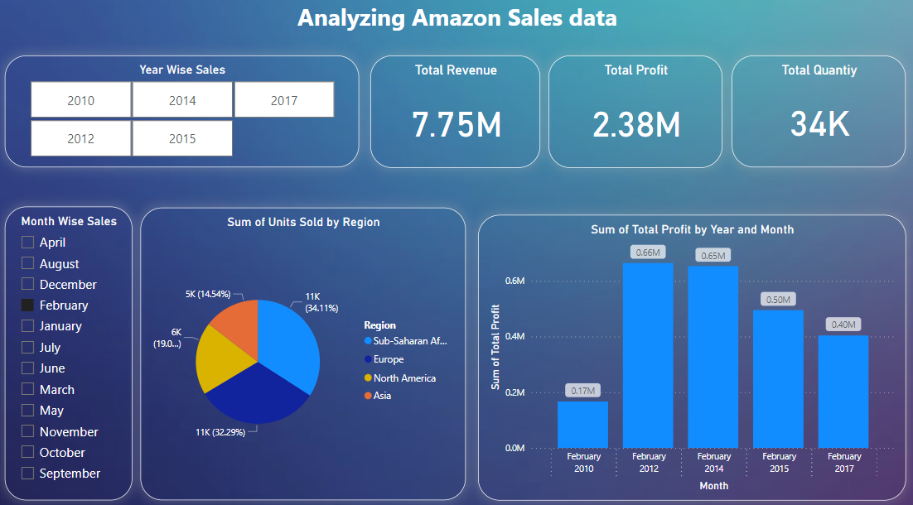

1.1 Cards

The card slicers that shows Revenue, Revenue Last Year, Total Sales Quantity, Total Profit Margin

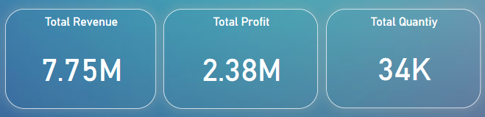

1.2 Monthly Sales Trend

The area chart for monthly, yearly and quarterly sales

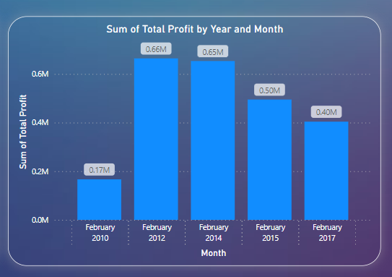

1.3 Revenue by Country

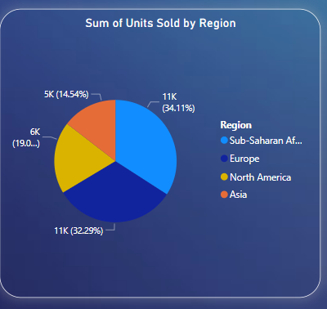

# 2. Sales Analysis

